
Credit card Details Binary Classification Problem
This dataset, which can be found in https://www.kaggle.com/datasets/rohitudageri/credit-card-details?select=Credit_card_label.csv, contains information about credit card applicants. It consists of 53 features and 1548 samples and it is used to predict whether an application for a credit card will be approved or denied. The dataset contains some categorical features which are encoded outside of Isalos using Python code.
Isalos version used: 2.0.6

Step 1: Import data from file
Right click on the input spreadsheet (left) and choose the option “Import from File”. Then navigate through your files to load the one with the credit card data.

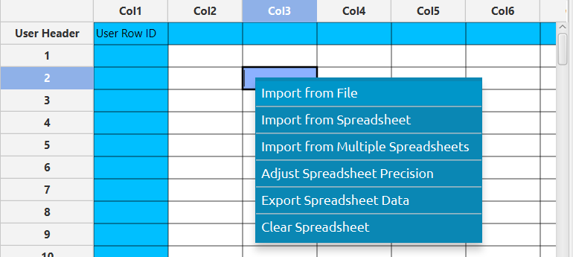

The data will appear on the left spreadsheet.
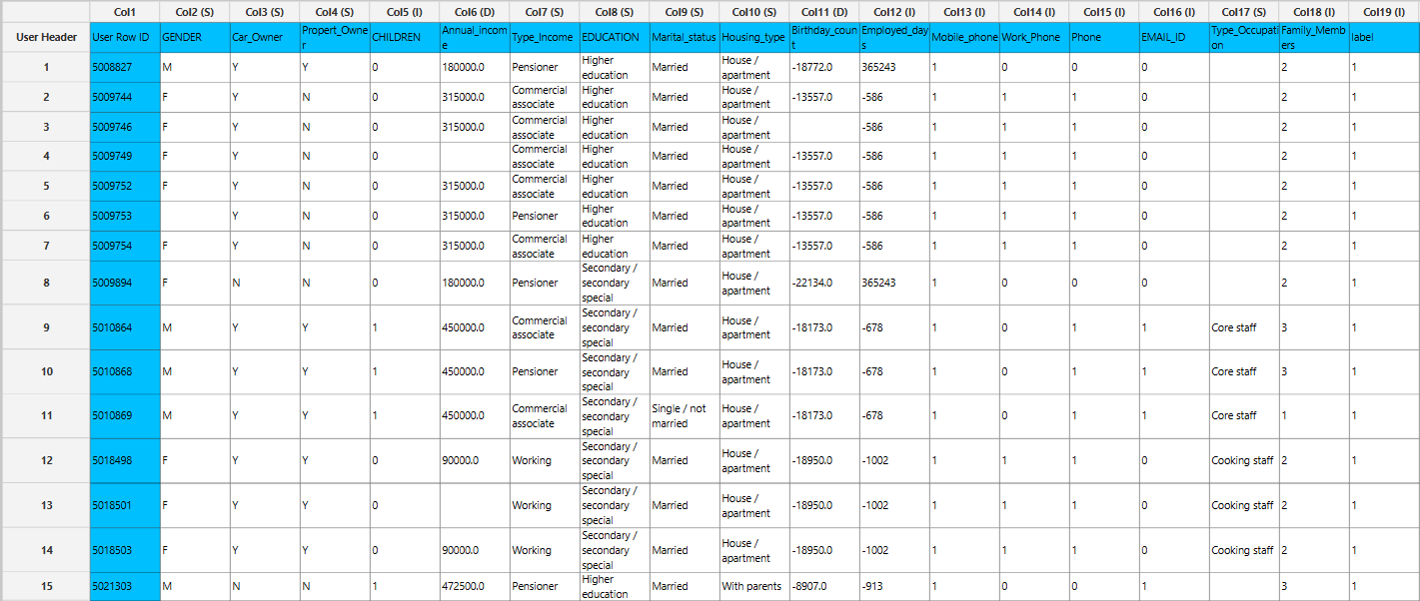

Step 2: Manipulate data
We can select all the columns to be used. On the menu click on Data Transformation $→$ Data Manipulation $→$ Select Column(s) and select all columns.
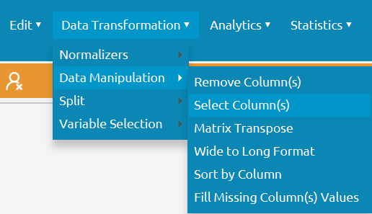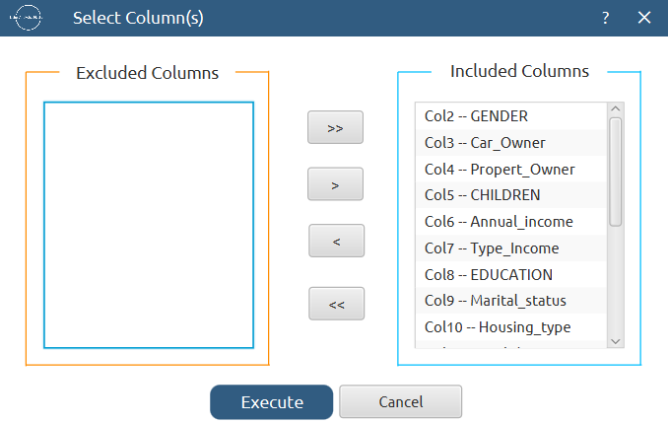

All of the data will appear in the output (right) spreadsheet. This tab can be renamed “IMPORT” by right-clicking on it and choosing the “Rename” option.

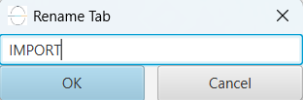

Step 3: Fill missing data
This dataset includes some missing values therefore we need to fill them appropriately. Create a new tab by pressing the “+” button on the bottom of the page with the name “FILL_MISSING” which we will use for filling the missing values.
Import data into the input spreadsheet of the “FILL_MISSING” tab from the output of the “IMPORT” tab by right-clicking on the input spreadsheet and then choosing “Import from Spreadsheet”.


To fill the missing data, choose: Data Transformation $→$ Data Manipulation $→$ Fill Missing Column(s) Values. Choose to fill the numerical features with their mean values and the categorical features with their most common values.
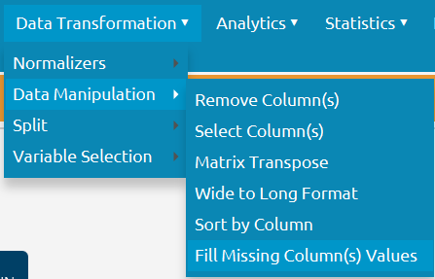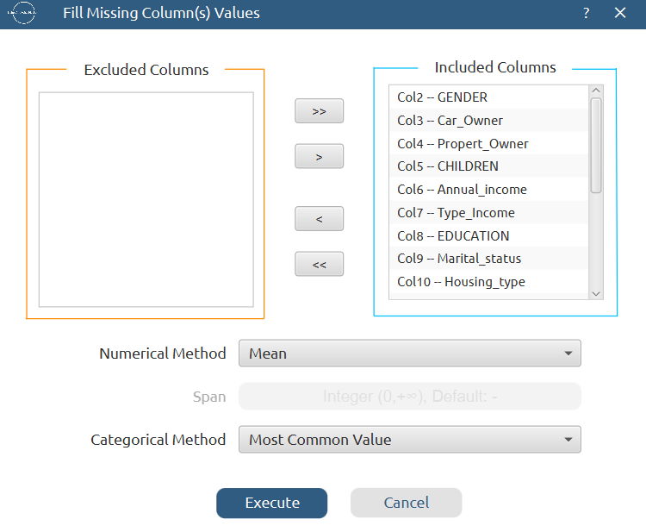

The results will appear on the output spreadsheet.
Export the results in a csv file by right-clicking on the output spreadsheet and selecting “Export Spreadsheet Data”.
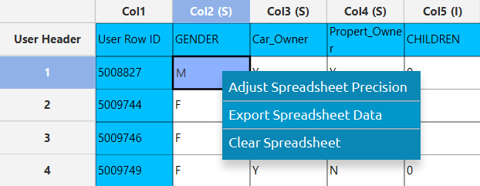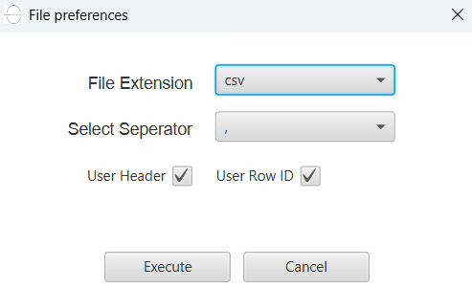

Afterwards, apply one-hot encoding on the categorical features of the dataset, which are: "GENDER", "Car_Owner", "Propert_Owner", "Type_Income", "EDUCATION", "Marital_status", "Housing_type" and "Type_Occupation".

Step 4: Split data
Create a new tab by pressing the “+” button on the bottom of the page with the name “TRAIN_TEST_SPLIT” which we will use for splitting the train and test set.
Import data into the input spreadsheet of the “TRAIN_TEST_SPLIT” tab from the one-hot encoded dataset by right-clicking on the input spreadsheet and then choosing “Import from File”. Then navigate through your files to load the one with the encoded dataset.
Split the dataset by choosing Data Transformation $→$ Split $→$ Random Partitioning. Then choose the “Training set percentage” and the column for the sampling as shown below:

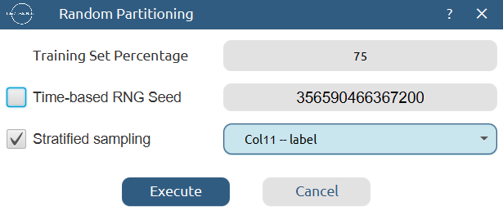

The results will be two separate spreadsheets, “TRAIN_TEST_SPLIT: Training Set” and “TRAIN_TEST_SPLIT: Test Set”, which will be available to import into the next tabs.

Step 5: Normalize the training set
Create a new tab by pressing the “+” button on the bottom of the page with the name “NORMALIZE_TRAIN_SET”.
Import into the input spreadsheet of the “NORMALIZE_TRAIN_SET” tab the train set from the output of the “TRAIN_TEST_SPLIT” tab by right-clicking on the input spreadsheet and then choosing “Import from Spreadsheet”. From the available Select input tab options choose “TRAIN_TEST_SPLIT: Training Set”.

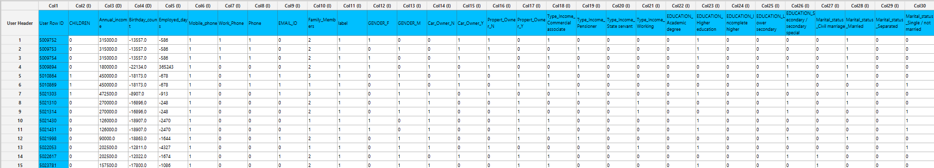

Normalize the data using Z-score: Data Transformation $→$ Normalizers $→$ Z Score and select all the numerical feature columns except “Mobile_phone”.

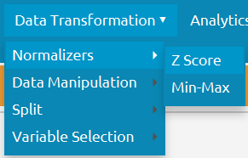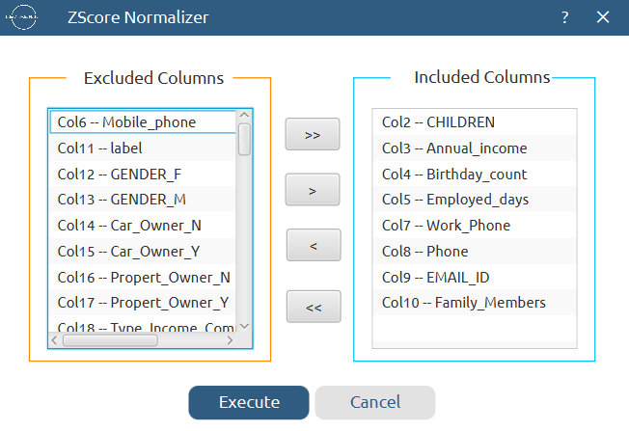

The results will appear on the output spreadsheet.
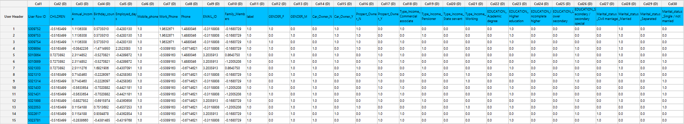

Step 6: Normalize the test set
Create a new tab by pressing the “+” button on the bottom of the page with the name “NORMALIZE_TEST_SET”.
Import into the input spreadsheet of the “NORMALIZE_TEST_SET” tab the test set from the output of the “TRAIN_TEST_SPLIT” tab by right-clicking on the input spreadsheet and then choosing “Import from Spreadsheet”. From the available Select input tab options choose “TRAIN_TEST_SPLIT: Test Set”.

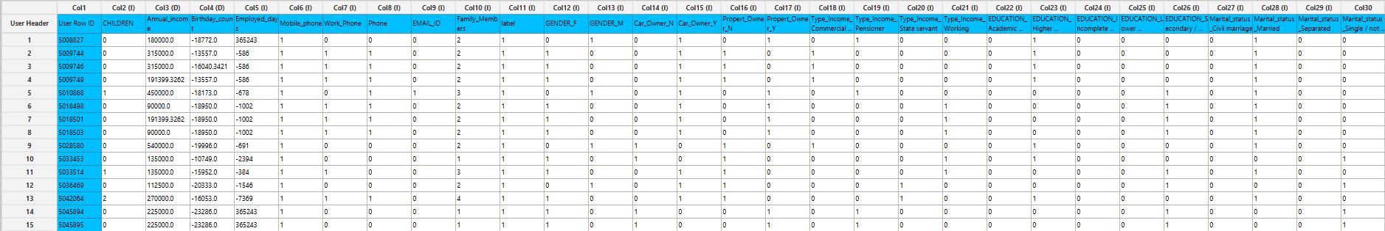

Normalize the test set using the existing normalizer of the training set: Analytics $→$ Existing Model Utilization $→$ Model (from Tab:) NORMALIZE_TRAIN_SET

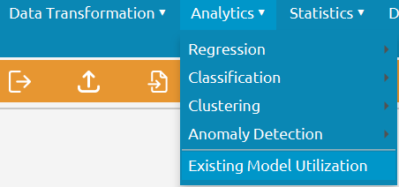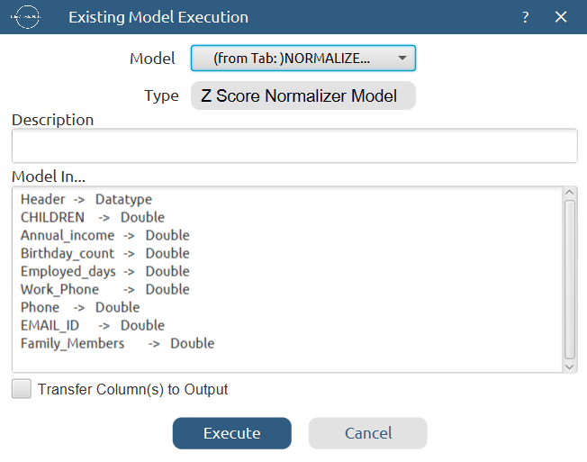

The results will appear on the output spreadsheet.
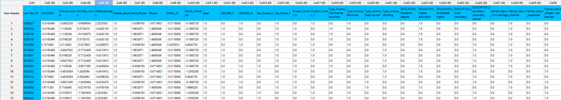

Step 7: Train the model
Create a new tab by pressing the “+” button on the bottom of the page with the name “TRAIN_MODEL(.fit)”.
Import data into the input spreadsheet of the “TRAIN_MODEL(.fit)” tab from the output of the “NORMALIZE_TRAIN_SET” tab by right-clicking on the input spreadsheet and then choosing “Import from Spreadsheet”.
Use the XGBoost method to train and fit the model: Analytics $→$ Classification $→$ XGBoost

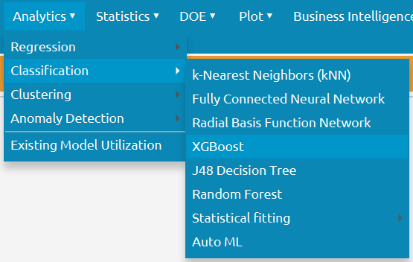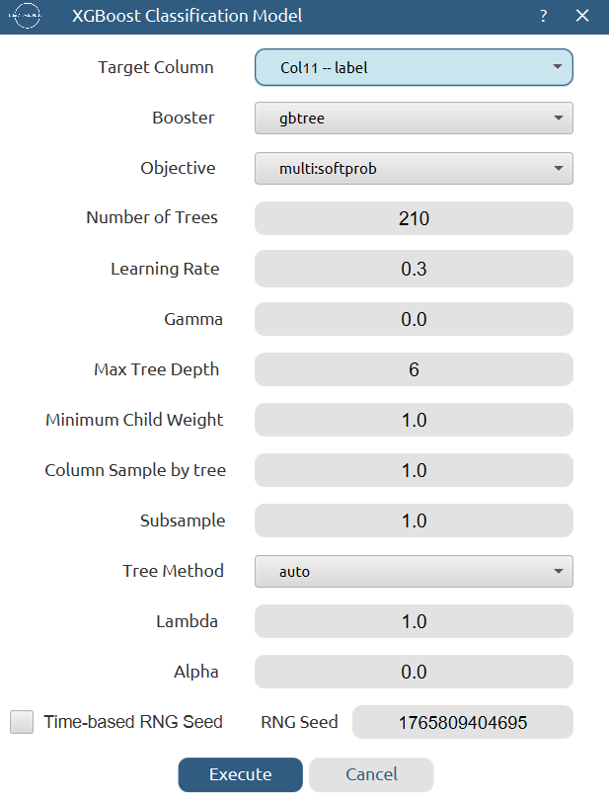

The predictions will appear on the output spreadsheet.
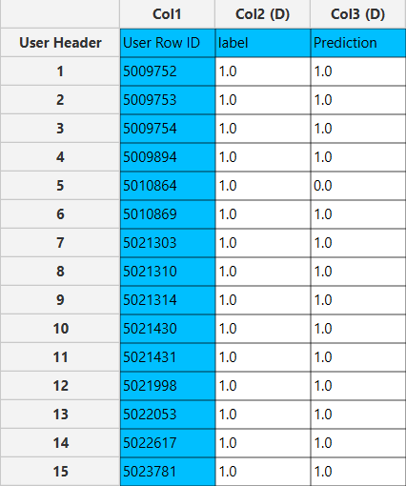

Step 8: Validate the model
Create a new tab by pressing the “+” button on the bottom of the page with the name “VALIDATE_MODEL(.predict)”.
Import data into the input spreadsheet of the “VALIDATE_MODEL(.predict)” tab from the output of the “NORMALIZE_TEST_SET” tab by right-clicking on the input spreadsheet and then choosing “Import from Spreadsheet”.
To validate the model: Analytics $→$ Existing Model Utilization$→$ Model (from Tab:) TRAIN_MODEL(.fit). Choose the column “label” to be transferred to the output spreadsheet.

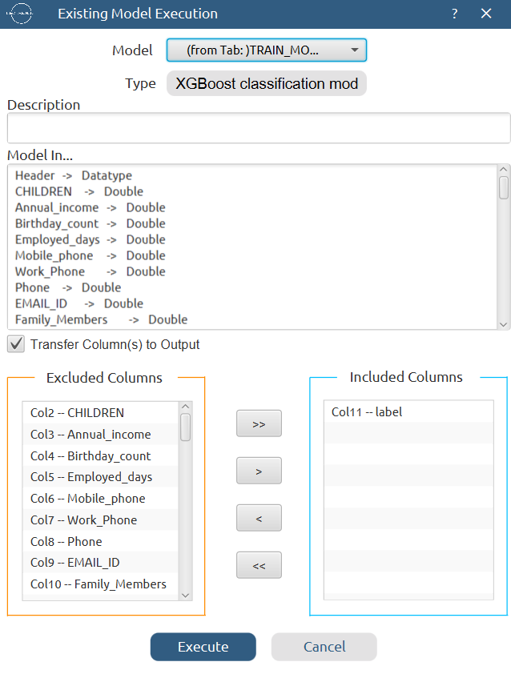

The predictions will appear on the output spreadsheet.
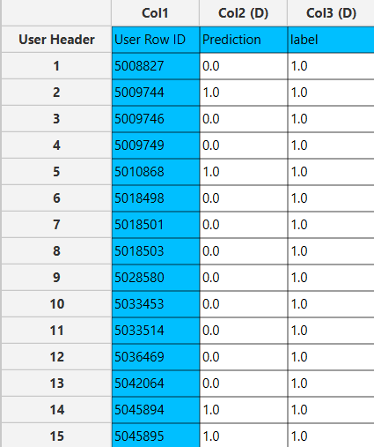

Step 9: Statistics calculation
Create a new tab by pressing the “+” button on the bottom of the page with the name “STATISTICS_ACCURACIES”.
Import data into the input spreadsheet of the “STATISTICS_ACCURACIES” tab from the output of the “VALIDATE_MODEL(.predict)” tab by right-clicking on the input spreadsheet and then choosing “Import from Spreadsheet”.
Calculate the statistical metrics for the classification: Statistics $→$ Model Metrics $→$ Classification Metrics
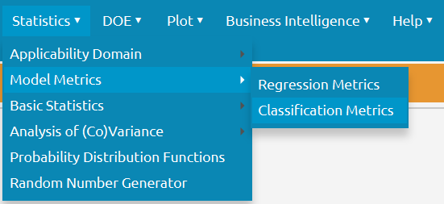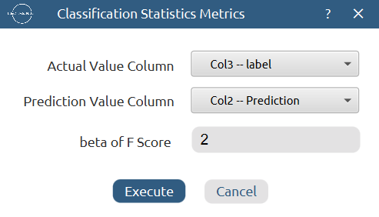

The results will appear on the output spreadsheet.
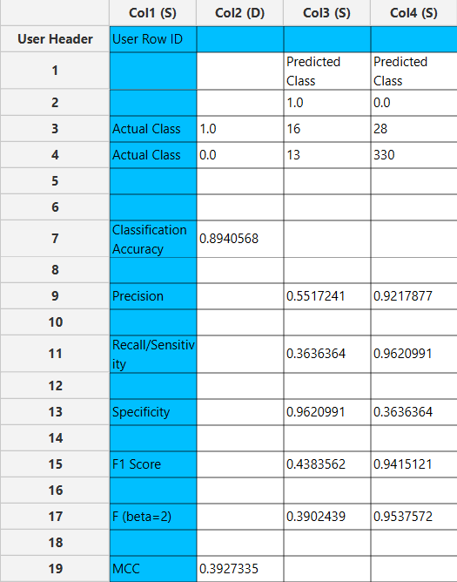

Step 10: Reliability check for each record of the test set

Step 10.a: Create the domain
Create a new tab by pressing the “+” button on the bottom of the page with the name “EXCLUDE_LABEL”.
Import data into the input spreadsheet of the “EXCLUDE_LABEL” tab from the output of the “NORMALIZE_TRAIN_SET” tab by right-clicking on the input spreadsheet and then choosing “Import from Spreadsheet”.
Manipulate the data to exclude the target column “label” and the one-hot encoded columns: Data Transformation $→$ Data Manipulation $→$ Select Column(s)
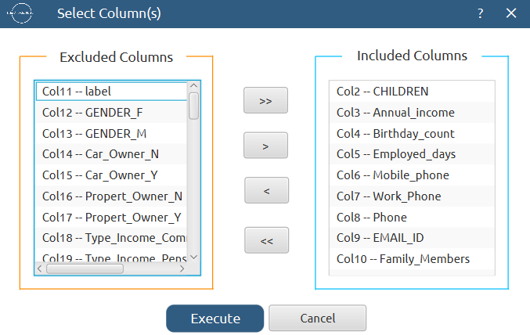

The results will appear on the output spreadsheet.
Create a new tab by pressing the “+” button on the bottom of the page with the name “DOMAIN”.
Import data into the input spreadsheet of the “DOMAIN” tab from the output of the “EXCLUDE_LABEL” tab by right-clicking on the input spreadsheet and then choosing “Import from Spreadsheet”.
Create the domain: Statistics $→$ Applicability Domain $→$ APD
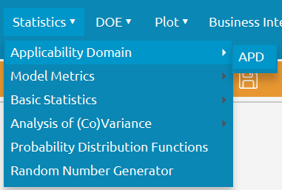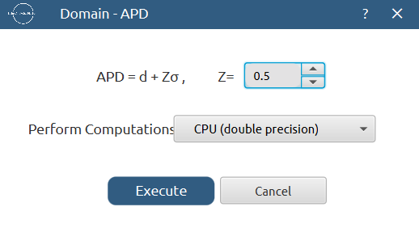

The results will appear on the output spreadsheet.
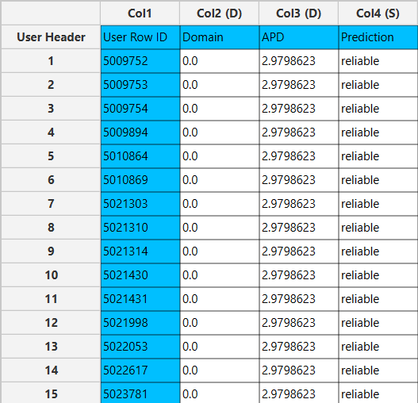

Step 10.b: Check the test set reliability
Create a new tab by pressing the “+” button on the bottom of the page with the name “EXCLUDE_LABEL_TEST_SET”.
Import data into the input spreadsheet of the “EXCLUDE_LABEL_TEST_SET” tab from the output of the “NORMALIZE_TEST_SET” tab by right-clicking on the input spreadsheet and then choosing “Import from Spreadsheet”.
Manipulate the data to exclude the target column “label” and the one-hot encoded columns: Data Transformation $→$ Data Manipulation $→$ Select Column(s)

The results will appear on the output spreadsheet.
Create a new tab by pressing the “+” button on the bottom of the page with the name “RELIABILITY”.
Import data into the input spreadsheet of the “RELIABILITY” tab from the output of the “EXCLUDE_LABEL_TEST_SET” tab by right-clicking on the input spreadsheet and then choosing “Import from Spreadsheet”.
Check the Reliability: Analytics $→$ Existing Model Utilization$→$ Model (from Tab:) DOMAIN
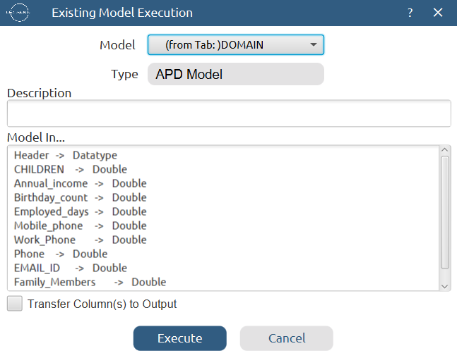

The results will appear on the output spreadsheet.
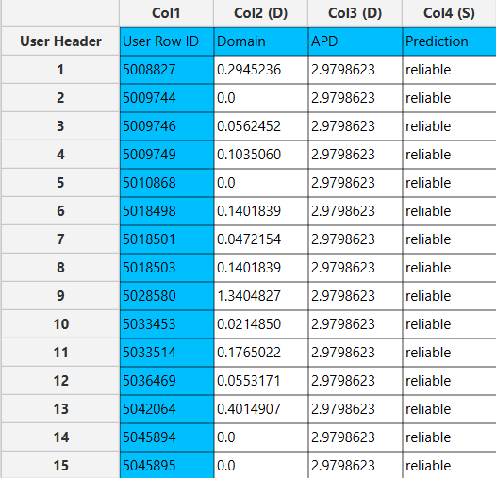

Final Isalos Workflow
Following the above-described steps, the final workflow on Isalos will look like this:
